DS 522 Data Acquisition and Analytics
HOS06Ab Cleaning and Prepping Data with PBI

Please capture the screenshots from the specified steps of the HOS06A-2 and HOS06A-3 exercises into this document. Save this document as a PDF for submission.

- Power BI Dashboard or Home Page after installation:
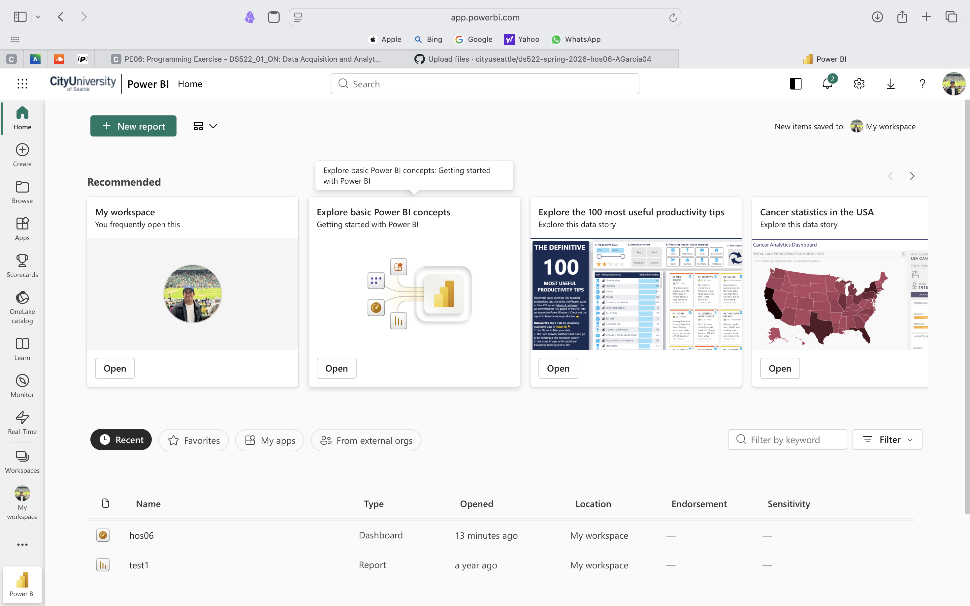
- FlightDelays table after filtering to show rows with DepDelay values greater than 15:
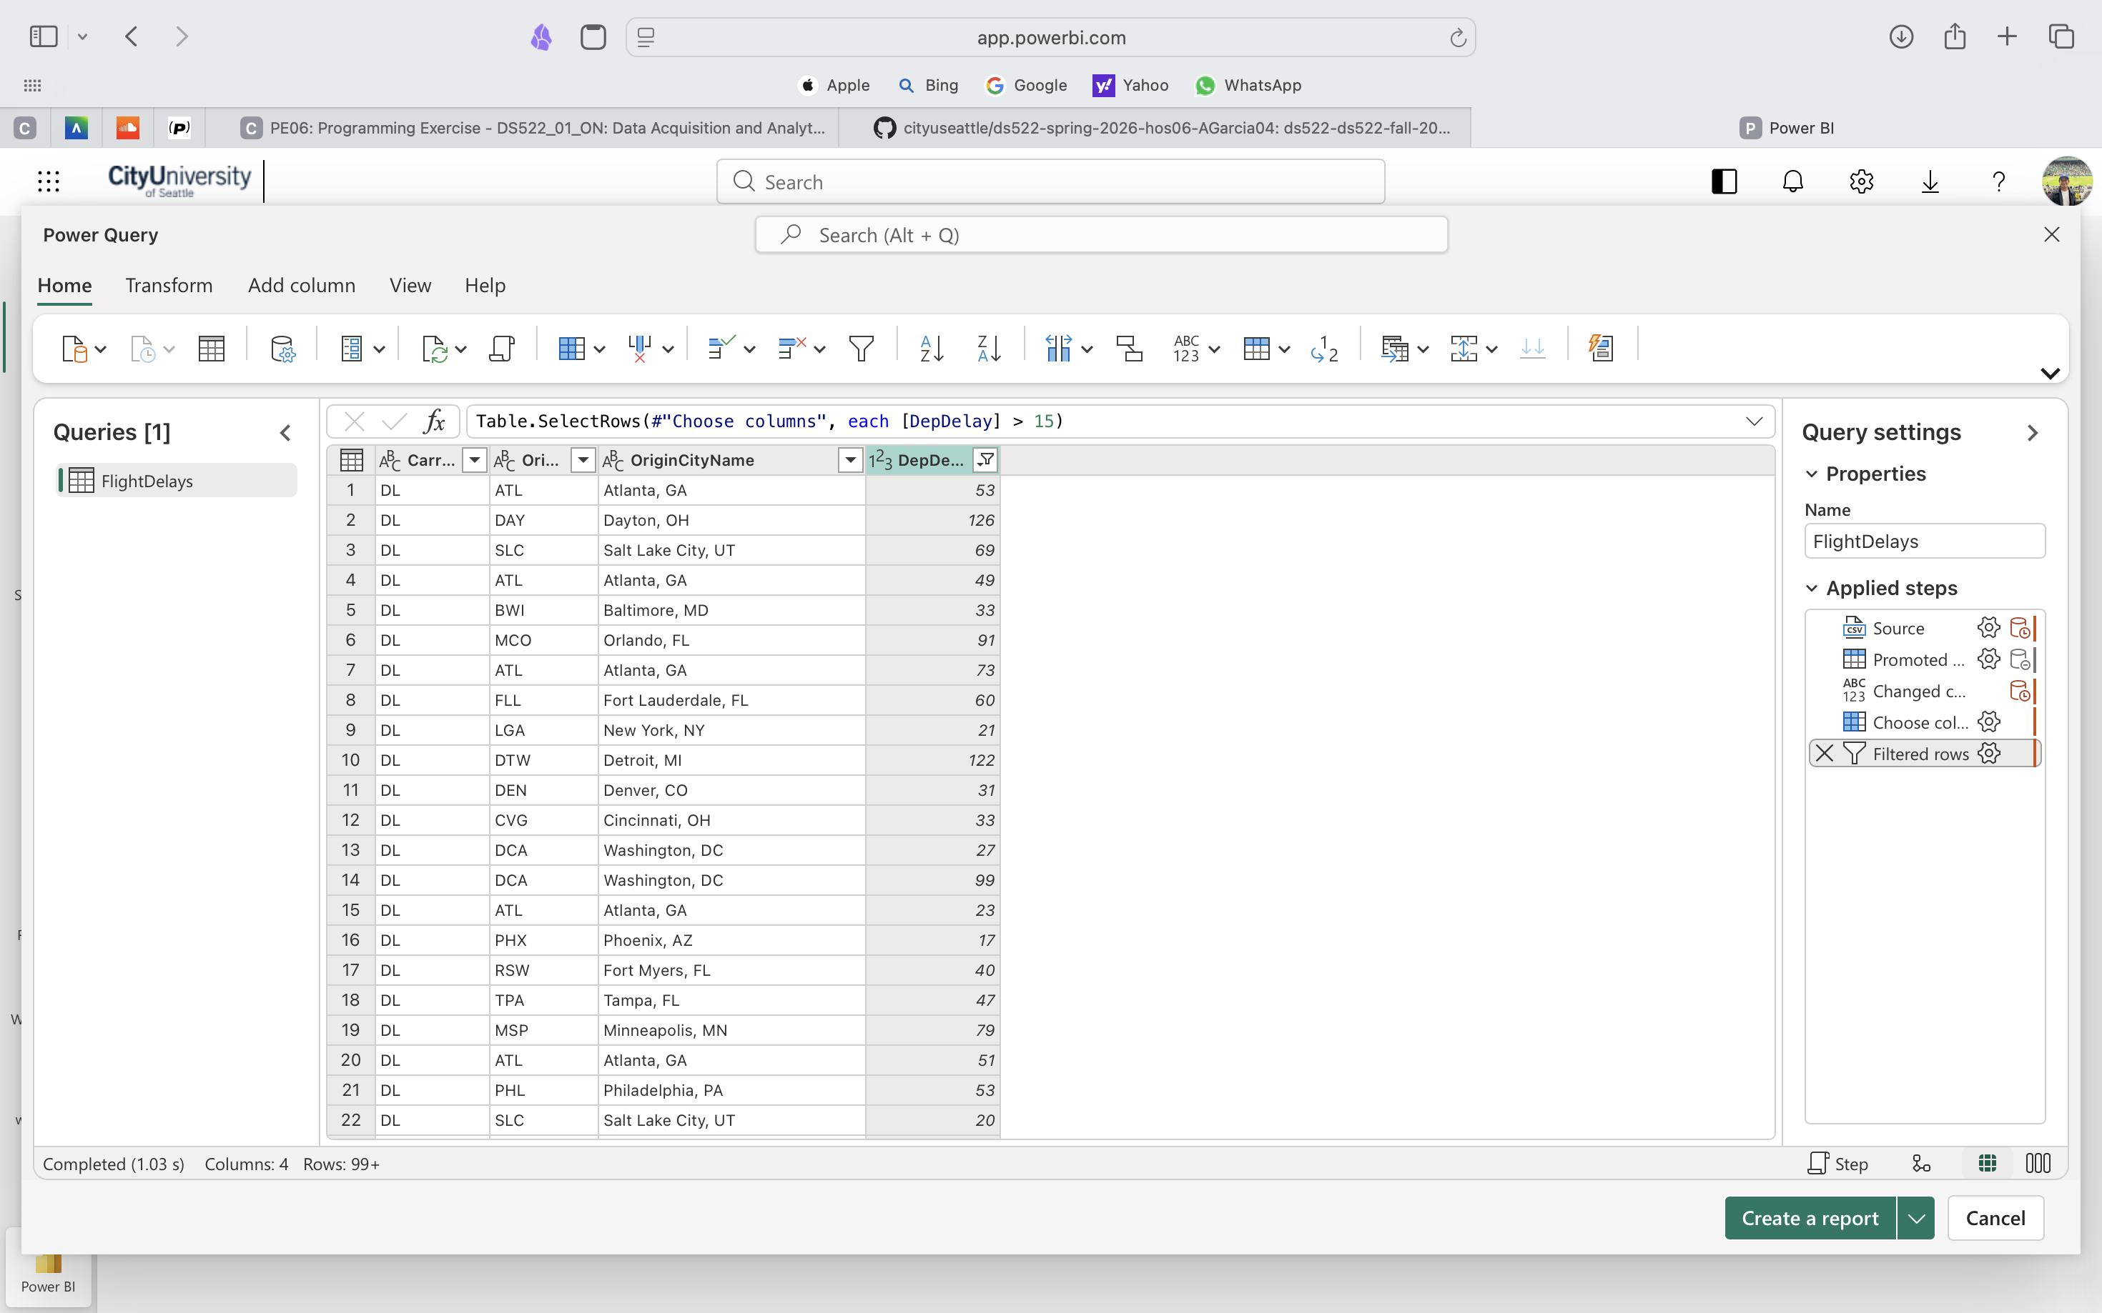

- Power Query Editor window after editing West Palm Beach/Palm Beach to Palm Beach:
